ANALYSIS OF FINANCIAL PERFORMANCE OF
EVEREST BANK LIMITED

A Project Work Report

By

Ananda Ojha

T.U.Regd.No.: 7-2-554-2-2020
Exam Roll no.: 705540013

College Name: Aishworya Multiple campus

Submitted to

The Faculty of Management
Tribhuvan University Kathmandu, Nepal

In Partial fulfillment of the requirements for the degree of
BACHELOR OF BUSINESS STUDIES (BBS)
Kathmandu, Nepal
June, 2025

Declaration

I hereby declare that the project work entitled “ANALYSIS OF THE FINANCIAL
PERFORMANCE OF EVEREST BANK LIMITED” submitted to the Faculty of
Management, Tribhuvan University, Kathmandu is an original piece of work under the supervision of Liladhar Sapkota, faculty member, Aishworya Multiple Campus and is submitted in partial fulfillment of the requirements for the award of the degree of Bachelor of Business Studies (BBS). This project work report has not been submitted to any other university or institution for the award of any degree or diploma.
Ananda Ojha
Date:2082/03/06

Supervisor’s Recommendation

The project work report entitled “ANALYSIS OF FINANCIAL PERFORMANCE OF EVEREST BANK LIMITED” submitted by Ananda Ojha of Aishworya Multiple Campus is prepared under my supervision as per the procedure and format requirements laid by the Faculty of Management, Tribhuvan University, as partial fulfillment of the requirements for the award of the degree of Bachelor of Business Studies (BBS). I, therefore, recommend the project work report for evaluation.

Signature:

Mr. Ananda Ojha

Date: 2082/03/06

Endorsement

We hereby endorse the project work report entitled “ANALYSIS OF FINANCIAL
PERFORMANCE OF EVEREST BANK LIMITED” submitted by Ananda Ojha of Aishworya Multiple Campus in partial fulfillment of the requirements for award of the Bachelor of Business Studies (BBS) for external evaluation.

Signature: Signature:
Name of Chairman: Name of Campus Chief:
Date: Date:

Acknowledgements

This field work report entitled "A Report on Financial Performance Analysis of Everest Bank Limited” has been prepared in partial fulfillment for the degree of Bachelor of Business Studies (BBS) under the teachers of Aishworya Multiple Campus. It is my privilege of getting helps and cooperation from different persons. It is not possible to enumerate the names of all of them. However, it will be matter of injustice if I forget the names of those personalities whose valuable suggestions and co-operation escorted to complete this field work report.
First and foremost, I would like to offer special thanks to Liladhar Adhikari for their proper suggestions. I would like to thank all the staff of the Everest Bank Limited for their full support in providing all the necessary data, which helped me in preparing this report. I could not remain without thanking to my teachers and lecturers who all helped me during my study of BBS and during preparation of this report.
Ananda Ojha
BBS 4th Year
Aishworya Multiple Campus

List of tables:
Table 1: Cash and Bank Balance to Investment Ratio
Table 2: Cash and Bank Balance to Total Deposit Ratio
Table 3: Cash and Bank balance to Total Assets Ratio
Table 4: Current Ratio
Table 5: Return on Shareholder’s Fund
Table 6: Return on Total Assets
Table 7: Earning Per Share
Table 8: Dividend per Share
Table 9: Loan and Advances to Fixed Deposit Ratio
Table 10: Loan and Advances to Total Deposit Ratio Table 11: Loan and Advances to Total Assets

List of graphs:
Graph 1: Cash and Bank Balance to Investment Ratio
Graph 2: Cash and Bank Balance to Total Deposit Ratio
Graph 3: Cash and Bank balance to Total Assets Ratio
Graph 4: Current Ratio
Graph 5: Return on Shareholder’s Fund
Graph 6: Return on Total Assets
Graph 7: Earning Per Share
Graph 8: Dividend per Share
Graph 9: Loan and Advances to Fixed Deposit Ratio
Graph 10: Loan and Advances to Total Deposit Ratio
Graph 11: Loan and Advances to Total Assets

Abbreviations
CB | Commercial Bank
CEO | Chief Executive Officer
CBB | Cash and Bank Balance
CV | Coefficient of Variation
DPS | Divedend per Share
EBL | Everest Bank Limited
EPS | Earning per share
i.e. | That is
Ltd. | Limited
NRB | Nepal Rastra Bank
NPAT | Net Profit After Tax
P&L Account | Profit and Loss Account
ROA | Return on Assets
ROE | Return on Equity
SD | Standard Deviation
TD | Total Deposit

CHAPTER-I

INTRODUCTION

1.1. Background of the Study

1.1.1. Meaning of Financial Analysis
Financial statement analysis is the process of analyzing a company's financial statements for decision-making purposes and to understand the overall health of an organization. Financial statements record financial data, which must be evaluated through financial statement analysis to become more useful to investors, shareholders, managers, and other interested parties. It is the method of evaluating past, present, and projected performance of a company. Analysts track performance measures across financial statements using several different methods for financial statement analysis, including vertical, horizontal, and ratio analysis. It helps to analyze whether an entity is stable, solvent, liquid or profitable enough to warrant a monetary investment. It is therefore essential to analyze the financial statement to know the actual financial performance and financial position of the organization.

1.1.2. Elements of the Financial analysis:
Profitability
Profitability is the most common measure of an enterprise including the banking industry. Profitability refers to the state or condition of yielding or earning a financial profit or gain. It refers to the ability of the company to use its resources to generate revenues in excess of its expenses. Similarly, profitability ratios are generally considered to be the basic bank financial ratio in order to evaluate how well bank is performing in terms of profit. For the most part, if a profitability ratio is relatively higher as compared to the competitor(s), industry averages, guidelines, or previous years’ same ratios, then it is taken as indicator of better performance of the bank.
Liquidity
Liquidity refers to a company's ability to pay its current bills and expenses. In other words, liquidity relates to the availability of cash and other assets to cover accounts payable, short term debt, and other liabilities. It is characterized by the use of converting an asset into money at a little cost. In the assets side of the balance sheet of the commercial bank, will be liquid assets, which can be easily converted into cash- such assets are called liquid assets. Liquidity can also be defined as the bank’s ability to meet immediate maturing liabilities. Liquid assets mainly include cash and bank balances money at call and short notice, investment in government securities such as treasury bills, development bonds, saving bonds etc.
The liquidity management function of a bank is regular one. It is known that bank liquidity is the most sensitive and importance aspect. A bank can’t be imagined without liquidity. The banks and financial institutions should keep the stock of liquid assets in the ratio of their deposit liability, as fixed by the Nepal Rastra Bank. The importance of liquidity is as follows:
- To meet the expenses for the banks daily administrative work.
- To pay all sorts of deposits.
- To control the economic fluctuation and to keep safe from the risk.
- To fill the demand of the debtor.
- Providing security to the bank.

Leverage Ratio:
Companies rely on a mixture of owners' equity and debt to finance their operations. A leverage ratio is any one of several financial measurements that look at how much capital comes in the form of debt (loans), or assesses the ability of a company to meet financial obligations.

Activity ratio:
Activity ratios measure the relative efficiency of a firm based on its use of its assets, leverage or other such balance sheet items and are important in determining whether a company's management is doing a good enough job of generating revenues and cash from its resources.

1.1.3. Commercial Banking Scenario in Nepal
Nepal Rastra Bank is the central bank of Nepal. It was established in Baisakh 14, 2013 B.S. under Nepal Rastra Bank Act, 2012. It formulates policy to control the function carried out by the banks. At present, NRB has allowed the commercial banks to fix the interest rate on deposit as well as credit on the basis of cost and availability of financial resources. This policy framework has introduced and element of competitiveness in the financial sectors.
The commercial banks are contributing in the economic development. Resources for economic development are made available by the commercial banks which ultimately aids to the overall development of the nation.
In Nepal, “Nepal Bank Limited” was the first commercial bank established in 1994 under Nepal Bank Act, 1993. Under Banijya Bank Act, 2021 B.S. the government launched “Rastriya Banijya Bank”. It was fully financed by the government resources. Likewise, “Agriculture Development Bank” was established on January 2, 1968 under full ownership of the government for the purpose of developing agriculture sector.
As per the latest data from Nepal Rastra Bank, at present, there are 20 commercial banks, 16 development banks and 51 Microfinance companies operating in Nepal. Currently there are seven joint venture banks in operation in Nepal with there branches located in different part of the country.

1.2. Profile of Organization
Everest Bank Limited
Everest Bank Limited (EBL) is one of the leading commercial banks of Nepal. It provides professional and customer friendly banking service in Nepal. It is a registered ‘A’ class commercial bank, having Joint Venture with Punjab National Bank (PNB), India.
Banking services are provided through the wide network of branches and counters to the entire nation and different section of the society. Deriving strength from the Joint Venture Partner, Everest Bank Limited is steadily growing in size and operation in last 24 years.
Currently, the bank has network of total 86 branches, located inside and outside the valley. Different type of saving account and fixed deposit account are offered by the bank to facilitate fund accumulation targeting office and institutions, women, youth, and deprived sectors. In the same way it also provides various type of loan facilities like home loan, education loan, vehicle loan, loan against insurance policy and major corporate loan. Its product and service aim at satisfying the needs and desire of different customers. It is one of the first banks to introduce Any Branch Banking System (ABBS) in Nepal. It also introduced branchless banking system for the first time in Nepal to cover unbanked sector of Nepalese society through biometric machine. EBL was bestowed with the “NICCI Excellence
Award” by Nepal India Chamber of Commerce for its spectacular performance under finance sector. Correspondingly, the bank was acknowledged as the “Highest Tax Payer among Commercial Banks” by Nepal Government for FY 2068/69.

Corporate Vision:
To be the Leading Commercial Bank with Pan Nepal presence and become a household name, providing wide range of financial products & service under on roof.
Mission Statement:
Its mission states “Growth through Banking for All”.
Motto
It defines its motto as follows:
- Consistent in term of Performance & Growth
- Strong in terms of its System & Procedures
- Dependable in terms of Return to all Stakeholders
Strategic Focus
The Bank has set itself the following broad goals:
- Mobilize Deposits through Current, Savings, Term & Call Deposit accounts and other instruments.
- Grant loans & advances with special thrust on Productive, SME as well as the Retail Segment.
- Provide Treasury Services following best international practices.
- Facilitates cross border payment services so as to strengthen remittance inflow.
- Provide custody services.
- Provide cash management services, insurance products and other financial services.
- Provide any other service businesses that regulator prescribes from time to time.

1.2.1 Shareholding Composition
Table 1: Present Shareholding Pattern of Bank
SN | Ownership | Percent
1 | Promoters | 39.14
2 | Punjab National Bank | 20.03
3 | Public | 40.83
Total |  | 100

1.2.2. EBL Network Overview
Table 2: EBL Network Overview
Province | Network
Province 1 | 18
Province 2 | 14
Province 3 | 46
Province 4 | 13
Province 5 | 22
Province 6 | 02
Province 7 | 13

1.2.3. No. of Staff
At present, there are more than thousand staffs in all branches of Everest Bank Limited.

1.2.4. Composition of Board of Directors
The Board of Directors of Everest Bank Limited is chaired by Dr. Bal Gopal Baidya along with five respective Directors. The managerial activities are governed by Mr.sudesh khaling, the respective Chief Executive officer (CEO) along with three Deputy General Managers.

1.3. Statement of Problem

A statement of problem is a brief description of an issue to be addressed or a condition to be improved upon. It aims in identifying and explaining the problem.
In present context of Nepal, commercial banks have good performance. On the basis of profitability and productivity of commercial banks, public have confidence in their performance. However, various environmental factors, state of economy, structure of capital and money market, government policies, taxation policies and various internal factors have influence upon financial performance and position of commercial banks. In these circumstances, it is highly useful to make the study on financial statement of Everest Bank Ltd.
Profitability position and stock prices are the general factors considered for evaluating the financial performance of Everest Bank Ltd. However, one can raise a question, “Are these the only factors to reflect the performance of the bank?”

Thus, the main problem of the study, is to inquire into the financial performance of Everest Bank Limited.
This study is targeted to find out answers to the following questions:
- What is the financial performance of Everest Bank Limited?
- Does the overall financial statement depict the financial position indicating any special strength and weakness of the Bank?
- Is Everest Bank Limited utilizing its assets efficiently?
- Everest Bank Limited is considered to be operationally efficient. But how far it is efficient?

In this context, the main purpose of the study is analyzing the financial performance of the Everest Bank Limited in terms of turnover, profitability, liquidity and efficiency in operation.

1.4. Objectives of the Study
The main objective of this study is to analyze the Financial Performance of Everest Bank Limited.
However, the specific objectives of study are as follows:
- To evaluate the financial position of Everest Bank Limited.
- To analyze the financial performances through the use of appropriate financial and analytical tools.
- To identify the profitability position i.e. Earning per share (EPS), Dividend per share (DPS) and Return on Asset (ROA).
- To measure the liquidity, solvency and efficiency.
- To determine the past, present and projected performance of the company.

1.5. Rationale of the Study
Optimum utilization of fund makes better impact on the economy of the nation. NBL is one of the governments owned national bank. So, it has been chosen for the study with below limitations:
- Importance to shareholders.
- Importance to the management bodies of the bank for the evaluation of the performance of bank.
- Importance to "outsiders" which are mainly the customers, financing agencies, stock exchanges etc.
- Importance to the government bodies or the policy makers such as the central bank
- Interested outside parties such as- investors, customers (depositors as well as credit takers), and competitors, personnel of the banks, stockbrokers, dealers, and market makers. So, this study helps to identify its unseen strength and weakness regarding financial as well as credit administration.

1.6. Literature Review

Literature review is the study of the available literature in one’s field of research. The literature provides us with the knowledge of the status of their field of research. Past study knowledge provides foundation to the present study. So, analyzing and presenting the following parts define this chapter:
- Origin of Bank ii. Conceptual/Theoretical review iii. Review of related journal, articles Detail explanation of the parts in this chapter is explained below:
i. Origin of Bank
The origin of the word ‘Bank’ is linked to: German word ‘Bank’ means a joint stock company, Latin word ‘Bank’ means a bench, Italian word ‘Bank’ means a bench and French word ‘banquet’ means a bench. The first bank was set up in Venice, Italy as a public bank, by the name ‘Bank of Venice’. Subsequently, ‘Bank of Barcelona’ in 1401 A.D. & ‘Bank of Geneva’ in 1407 A.D. were established. In 1609 A.D, “Bank of Amsterdam’, a famous bank was established. In reality, the history of modern banking had started from ‘Bank of England’ in 1694 A.D. But the modern joint stock banks were established in England only in 1833 A.D. In 1844 A.D., ‘Bank of England’ was established as a first central bank in the world. The ‘Banque De France’ was established in France in 1807 A.D. Later, the banks were established in other parts of the world.
- Theoretical Framework
The main objectives of the bank are to collect deposits as much as possible from the customers and to mobilize into the most profitable sector. If a bank fails to utilize its collected resources then it cannot generate revenue. Resource mobilization management of bank includes resource collection, investment portfolio, loans and advances, working capital, fixed assets management etc. It measures the extent to which bank is successful to utilize its resources. To measure the bank performance in many aspects, we should analyze its financial indicator with the help of financial statements.
Financial analysis is the process of identifying the financial strength and weakness of the concerned bank. It is the process of finding strength and weakness of the concerned bank. Financial statement analysis is a method of reviewing and analyzing a company's accounting reports (Financial statements) in order to gauge its past, present or projected future performance. This process of reviewing the financial statements allows for better economic decision making.
It is performed to determine the following:
  - Profitability
  - Liquidity
  - Solvency
  - Efficiency
The function or the performance of finance can be broken down into three major decisions i.e. the investment decision, the financing decision, and the dividend decisions. An optional combination of the three decisions will maximize the value of the firm.

- Review of literature
According to Brigham E.F., L.G. Gapenski, (1992), “financial analysis means assessing the viability, stability and profitability of a project. It also includes techniques used for determining the needs of a business.”
According to Ross, Peter S, (2000), “Financial analysis refers to the assessment of a business to deal with the planning, budgeting, monitoring, forecasting, and improving of all financial details within an organization.”
Tarawneh (2006) analyzed the financial statement of five Omani banks for the financial period 1999-2003. In addition, he used simple regression to estimate the impact of asset management, operation efficiency, and bank size on the financial performance of these banks. The results showed that financial performance of the banks was strongly and positively influenced by the operational efficiency, asset management, and bank size.
Almazari (2011) in his study attempted basically to measure the financial performance of seven Jordanian commercial banks for the period 2005-2009, by using simple regression in order to estimate the impact of independent variable represented by; the bank size, asset management, and operational efficiency on dependent variable financial performance represented by; return on assets and interest income size. It was found that banks with higher total deposits, credits, assets, and shareholders’ equity do not always mean that has better profitability performance. Also found that there exists a positive correlation between financial performance and asset size, asset utilization and operational efficiency, which was also confirmed with regression analysis that financial performance is greatly influenced by these independent factors.

Haque and Sharma (2011), their research studied the hypotheses tested imply that there are significant differences amongst Saudi banks. The financial performance of banks in Saudi Arabia is studied on the basis of financial variables and ratios through the help of Spearman's' rank correlation method. Although, benchmarking performance of banks is done using advanced linear programming models, this study attempts to develop an efficiency frontier on the basis of simple linear regression. Albeit certain restrictive assumptions, this study identifies Al Rajhi bank to be the best bank to which other banks could look up to and justifies this model on the basis of parsimony.

Almumani (2014) the purpose of his study is to analyze and compare the performance of Saudi banks that listed in stocks market for the period 2007-2011. The study is an evaluator in nature, drawing sources of information from secondary data. The financial performance of banks is studied on the basis of financial ratios and variables. Financial performance was measured by two approaches; trend analysis and inter-firm analysis. It was found that increasing of assets, operating expenses, and cost to income causes a decrease in Saudi bank’s profitability, while increasing of operating income causes an increase in the profitability of Saudi Banks. Analysis shows that all the variables of study have a positive mean value and all banks are generating income. Saudi joint venture banks proved to be more proficient in generating profits, absorbing loan losses and dominating in ROE, while, Saudi established banks have more capacity of absorbing asset losses and dominating in ROA.
Kumal (2015) evaluated the financial performance of M/s Kumari Bank Limited, a commercial bank in Nepal taking the period of three financial years in considerations, from FY 2011/12 to FY 2012/13. The results showed that the financial position of M/s Kumari Bank Limited is satisfactory and in good position.

In the Gulf, Samad (2004) investigated the performance of seven locally incorporated commercial banks during the period 1994-2001. Financial ratios were used to evaluate the credit quality, profitability, and liquidity performances. The performance of the seven commercial banks was compared with the banking industry in Bahrain which was considered a benchmark. The article applied a Student’s t-test to measure the statistical significance for the measures of performance. The results revealed that commercial banks in Bahrain were relatively less profitable, less liquid and were exposed to higher credit risk than the banking

1.7. Method of study
Research is an organized, systematic, data based, critical, scientific enquiry or investigation into specific problem, undertaken with the objective of finding answers or solutions to it. This study focuses on the planned and systematic dealing with the collection, analysis and interpretation of facts and figure. It consists of research design, population and sample study, sources of data, data processing procedure and technique of analyzing data. This chapter describes the methodology employed in this study.
For the purpose of achieving the objectives of study, the applied methodology will be used.

1.7.1 Research Design:
“Research design is a master plan specifying the methods and procedures for collecting and analyzing the needed information."- (Zikmund, 2007)
It is the formal plan of action for a research project or a blue print of the research project. It has the researchers to lay out their research questions, methodologies, implementation procedures, and data collection and analysis to conduct a research project. The research design then focuses on the data collection methods, the research instruments utilized, and the sampling plan to be followed.
Specifically, research design describes the general plan for collecting, analyzing and evaluating data after identifying the facts and findings.
What the researcher wants to know and What has to be dealt with in order to obtain the required information? (Wolf & Pant, 2002:50)
It includes an outline of what the investigator will do from writing the hypotheses and their operational implications to the final analysis of data. Generally, a common research design possesses the five basic elements viz.
- Selection of problem
- Methodology
- Data gathering.
- Data analysis and
- Report writing.

1.7.2 Population and Sample
Population refers to the entire group of people, events, or things of interest that the researcher wishes to investigate. Survey of each and every group of population by researcher is not normally possible. For the held research, a portion of the population is taken as the representation of the entire population. Sample of items and elements from the population are taken for conducting our study. It comprises some observations selected from the population.
There are altogether 28 commercial banks functioning all over the nation and most of their stocks are traded actively in the stock market. Here EBL have been selected as sample for our study. Similarly, financial statements of this bank for 5 years have been taken as samples for the same purpose.

1.7.3 Nature and Sources of Data
In regards to the primary data, some personal views and ideas of individual respondent are collected. But in case of entire study, secondary data which are used are basically of the following nature:
- Most of the data taken for the analysis is collected from the material published by the concerned banks through their annual reports.
- Since the stock of EBL is listed in NEPSE, the figures are all most reliable and suitable too.
In order to fulfill the objective of this research work, all the secondary data are collected, processed and tabulated in time series and bar diagram. The reliability of the data complied in the annual report of the bank is judged and confirmed by an independent auditor.
So, the major sources of secondary data used for this study are as follows:
- Annual Report of EBL (2070/71 to 2076/77) .
- Official Website of EBL
- NRB circulars.
- NRB directives.

1.7.4 Data Processing Procedures
Data collected from various sources are in raw form. The method of analysis is directed to find the actual financial performance of the bank. The obtained data are presented in the tabular form, diagrams and graph with the supporting interpretation. The collected data are accumulated in organized way and are grouped for calculation using the method given by the formulas.

1.7.5 Data Analysis Tools
Analysis and presentation of the data is the core of each and every research work. Financial and statistical tools are considered as the most reliable tools to accomplish the objective of the study. These tools are used in order to make the analysis more effective, convenient, reliable and authentic.
The various results obtained with the help of financial, accounting and statistical tools are tabulated under different headlines. Such results are interpreted to portray the current position and performance of the bank. Two kinds of tools have been used to achieve the certain goals.
1. Financial Tools
2. Statistical Tools
Financial Tools
It basically helps to identify the financial strengths and weakness of the firm by establishing relationship between the items of the financial position and statement of profit or loss account.
Financial tools are categorized into two parts. They are:
i) Ratio Analysis
Ratio analysis is the powerful tool of financial analysis. “A ratio is a mathematical relationship between two variables. It is significant for financial analysis. It also helps us to predict the future performance of a company based on study of ratios of earlier years.” (Benerjee: 1989,95)
Thus, ratio analysis is the part of whole process of analysis of financial statement to make decision regarding the output and credit for any business and industry. Quantitative relationship are established by the ratio which facilitates the qualitative judgement to be made.
They are presented below:
1. Liquidity Ratio:
Liquidity refers to a company’s ability to pay its current bills and expenses. So, liquidity ratios are used to measure the ability of a firm to meet its short-term obligations and from them the present cash solvency as well as ability to remain solvent in the event of adversities of the same can be examined. In other words, liquidity relates to the availability of cash and other assets to cover accounts payable, short-term debt, and other liabilities. It is characterized by the use of converting an asset into money at a little cost. Liquid assets mainly include cash and bank balances money at call and short notice, investment in government securities such as treasury bills, development bonds, saving bonds etc.
- Cash and Bank Balance to Total Investment Ratio:
This ratio shows the ability of banks immediate funds to cover their investment. Higher the ratio shows higher liquidity position and ability to cover the deposits and vice versa. It can be calculated by dividing ‘cash and bank balance’ by deposits. This ratio can be calculated using the following formula.
- Cash and Bank Balance to Total Deposits Ratio:
This ratio is computed to disclose the soundness of the company to compute cash and bank balance made of total deposits. It can be expressed as:
- Cash and Bank Balance to Total Assets Ratio:
- Current Ratio
Current Ratio is the ratio that indicates the relationship between current assets and current liabilities.
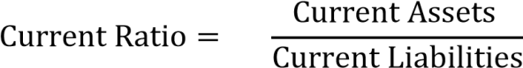

2. Profitability Ratio:
Profitability refers to the state or condition of yielding or earning a financial profit or gain. It refers to the ability of the company to use its resources to generate revenues in excess of its expenses. Similarly, profitability ratios are generally considered to be the basic bank financial ratio in order to evaluate how well bank is performing in terms of profit. For the most part, if a profitability ratio is relatively higher as compared to the competitor(s), industry averages, guidelines, or previous years’ same ratios, then it is taken as indicator of better performance of the bank.

- Return on Shareholder’s Fund:
This ratio, also called Return in Proprietor’s Fund or Return in Net worth. It measures the percentage of net profit to average shareholder’s fund.

- Return on Total Assets
Return on Total Assets measures the profitability of the total investment of the company.
The ratio is computed by dividing net income after tax by average total assets.
- Earnings per Share (EPS)
EPS simply shows the profitability of the firm on a per share basis. It is calculated from the point of view of the ordinary shareholders.

- Dividend Per Share (DPS):
This ratio is calculated by dividing the Dividend payable to Equity Shareholders by Number of Equity Shares.
C. Asset Management Ratio:
It is also known as turnover or efficiency ratio or assets management ratio; measures how efficiently the firm employs the assets. Turnover means; how much number of times the assets flow through a firm’s operations and into sales (Kulkarni, 1994:138). Greater rate of turnover or conversion indicates more efficiency of a firm in managing and utilizing its assets, being other things equal.
Various ratios are examined under this heading.

i) Loan and Advances to Total Deposits Ratio:
Commercial banks utilize the outsider’s fund for profit generation purpose. Loan and advances to deposit ratio shows whether the banks are successful to utilize the outsiders funds (i.e. total deposits) for the profit generating purpose on the credit and advances or not.
ii) Loan and Advances to Fixed Deposit Ratio:
Fixed deposits are the long-term interest bearing obligations and credits and advances is the major sources of investment. This ratio measures how many times the amount is used in credits and advances in comparison to fixed deposit for the income generating purpose.
iii)Loan and Advances to Total Assets Ratios:
It measures the ability in mobilizing total assets into credits and advances for profit generating income. The following formula is used to obtain this ratio.
2)Statistical Tools
For supporting the study, statistical tools have been used under it.
- Mean:
The statistical mean refers to the mean or average that is used to derive the central tendency of the data in question. It is determining by adding all the data points in a population and then dividing by total number of points.
It can be calculated as:

Mean = 
- Standard Deviation:
Standard deviation is a statistic used as a measure of the dispersion in a distribution, equal to the square root of the arithmetic mean of the squares of the deviations from the arithmetic mean.
It can be calculated as:

S.D.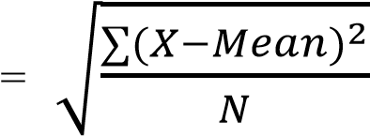
- Coefficient of variance:
It is a standardized measure of dispersion of a profitability distribution. It is often expressed as a percentage, and is defined as the ratio of the standard deviation to the mean.
It can be calculated as:
CV= 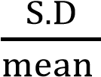

1.8. Limitation of the study
Limitation tends to narrow the area of study. It is caused due various undeniable circumstances.
The major limitations of this study are mentioned below:
- The Research is based on records of 7 fiscal years’ analysis only i.e. from FY 2070/71 to FY 2076/77.
- The researcher has used only some statistical tools for presentation and analysis of data.
- Most of the data used in this study are based on secondary sources mainly official website of Everest Bank Limited.
- The main focus is given to the quantitative aspect rather than qualitative aspect.
- The study is based on Everest Bank Limited only.
- It is only for partial fulfillment of Bachelor of Business Studies (BBS).

CHAPTER – II

RESULTS AND FINDINGS

2.1 Introduction:
This chapter deals with the presentation, analysis and interpretation of relevant data of Everest Bank Limited to fulfill the objective of this study. According to the research methodology as mentioned in the third chapter of this study the data have been analyzed competently. The purpose of this chapter is to introduce mechanism of data analysis and interpretation. Different type of analytical methods and tools such as financial ratio analysis and statistical analysis are used.

2.2 Financial Statement Analysis:
Financial statement analysis is the process of analyzing a company’s financial statement for decision making purposes and to understand the overall health of an organization. Financial analysis is done by applying various financial tools in order to have clear picture on the viability of the project. It is the method of evaluating past, present, and projected performance of a company. The financial analysis is done to ascertain the liquidity, profitability, leverage, debt servicing and interest servicing ability of the firm. The concept of financial statement analysis has been already discussed in previous chapter. Here, we study and analyze the data by using accounting tools.

2.2.1 Liquidity Ratio:
Liquidity refers to the ability of a firm to meet its short- term or current obligations. So liquidity ratios are used to measure the ability of a firm to meet its short-term obligations. Inadequate liquidity can lead to unexpected cash short falls that must be covered 5at excessive costs reducing profitability. In the worst case, inadequate liquidity can lead to the liquidity insolvency of the institution. To find - out the ability of the bank to meet their short-term obligations, which are likely to mature in the short period, the following ratios are developed under the liquidity ratios to identify the liquidity position.
i) Cash and Bank Balance to Investment Ratio:
This shows the ratio between cash & bank balance to Investment. Cash and bank balance is the outcome of deposit of customers plus other income and reserves of the bank. Bank is liable to customer to pay out upon demand of customers so we are trying to find the comparative study between them.

Table 3: Cash and Bank Balance to Investment Ratio (Amount in Rs.)

Fiscal  Year | Cash and Bank  Balance | Total Investment | Ratio | Percentage
2075/76 | -13,172,782,867 | 6,504,185,769 | 2.0 | -
2071/72 | 25,116,482,060 | 15,102,674,197 | 1.7 | -15%
2072/73 | 23,117,394,498 | 18,198,739,944 | 1.3 | -24%
2073/74 | 21,383,490,030 | 11,964,561,347 | 1.8 | 38%
2074/75 | 32,295,170,501 | 15,554,185,400 | 2.1 | 17%
2075/76 | 5,964,629,262 | 19,104,859,116 | 0.3 | -68.8%
2076/77 | 8,375,200,000 | 18,856,500,000 | 0.44 | -55.6%
Mean |  |  | 1.37
SD |  |  | 0.734
CV |  |  | 53.3%
Source: Annual Report of EBL

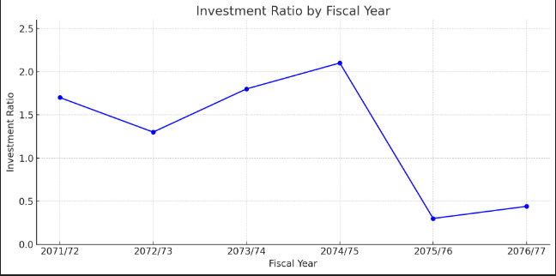
Figure 1: Cash and Bank Balance to Investment Ratio
The above Table 1 and Figure 1 reveal that the Cash and Bank Balance to Total Investment ratio has shown mixed trends over the years. The ratio increased during fiscal years 2073/74 and 2074/75, indicating an improvement in EBL's liquidity position during that time. EBL’s Cash and Bank Balance to Total Investment ratio is the highest at 2.1 times in 2074/75, and the lowest at 0.3 times in 2075/76. If we exclude this low ratio year as an outlier, the next lowest ratio is 1.3 times in 2072/73.
Ratios over the past years decreased in 2071/72 and 2072/73, while an increasing trend is observed in 2073/74 and 2074/75. However, in 2075/76 and 2076/77, the ratios fell drastically to 0.3 and 0.44 respectively, suggesting a significant drop in the cash-to-investment position of the bank. The average ratio (mean) is approximately 1.37 times, which is greater than 1. This implies that EBL was generally able to meet the demands of current depositors during the research period.
The standard deviation of the data analyzed is 0.734, which, although not very low, shows a moderate spread of the ratio values from the mean. This indicates some variability in the ratio but not extreme volatility. The coefficient of variation (CV) is approximately 53.3%, which represents the ratio of standard deviation to the mean. A higher CV indicates higher relative variability, suggesting moderate volatility in liquidity management.
A CV of 53.3% suggests that the investment ratio is relatively volatile, and risk-averse investors may need to consider this variability before making investment decisions. However, the bank still demonstrates a reasonable risk-return tradeoff over the observed fiscal years.

ii) Cash and Bank Balance to Total Deposit Ratio:
This cash & bank balance to total deposit ratio shows that percentage relation between them. It means the liquid balance available in respect to total deposit of the bank whereas the difference between the cash & bank balance to total deposit is said as the investment of the bank.

Table 4: Cash and Bank Balance to Total Deposit Ratio
(Amount in Rs.)
Fiscal Year | Cash and Bank  Balance | Total Deposit | Ratio | Percentage  (%)
2070/71 | 13,172,782,867 | 62,108,135,754 | 0.21 | -
2071/72 | 25,116,482,060 | 83,093,789,957 | 0.30 | 43%
2072/73 | 23,117,394,498 | 93,735,480,708 | 0.25 | -17%
2073/74 | 21,383,490,030 | 95,094,461,030 | 0.22 | -12%
2074/75 | 32,295,170,501 | 115,511,705,922 | 0.28 | 27%
2075/76 | 7,937,236,308 | 129,810,481,911 | 0.06 | -78.2%
2076/77 | 8,375,200,000 | 144,728,300,000 | 0.05 | -5.2%
Mean |  |  | 0.197
SD |  |  | 0.099
CV |  |  | 50.26 %
Source: Annual Report of EBL
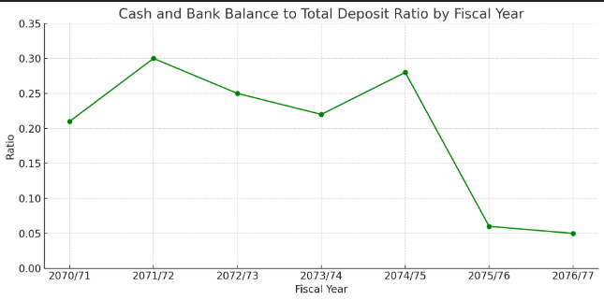
Figure 2: Cash and Bank Balance to Total Deposit Ratio
The above Table 2 and Figure 2 show that the Cash and Bank Balance to Total Deposit ratio of EBL follows a fluctuating trend over the observed fiscal years. EBL’s ratio reached its highest value of 0.30 times in 2071/72, while the lowest value of 0.05 times occurred in 2076/77. Over the years, the ratio increased in 2071/72, then decreased in 2072/73 and 2073/74. A slight recovery was observed in 2074/75, followed by a significant decline in 2075/76 and 2076/77, indicating a reduced liquidity buffer in recent years.
The average ratio is 0.197, which is significantly lower than 1, suggesting that EBL has substantially more total deposits than cash and bank balance. This could imply insufficient cash to pay off all customer deposits immediately. However, this is not necessarily a negative indicator—if the bank maintains strong credit terms with suppliers and minimal credit exposure to customers, it can still operate effectively. The standard deviation of the analyzed data is 0.099, which reflects moderate variability around the mean. Although not extremely high, this level of variation indicates that the ratio has not remained stable over time.
The coefficient of variation (CV) is 50.26%, indicating a moderate to high level of relative variability in the ratio. A higher CV suggests that the ratio has shown inconsistent performance, which might raise concerns for risk-averse investors. A lower CV is typically preferred for a better risk-return trade-off.
iii) Cash and Bank Balance to Total Assets Ratio:
This cash and bank balance to total assets ratio shows the relation between them. The cash flows to total assets ratio shows investors how efficiently the business is at using its assets to collect cash from sales and customers.

Table 5: Cash and Bank Balance to Total Assets Ratio
(Amount in Rs.)
Fiscal Year | Cash and Bank  Balance | Total Assets | Ratio | Percentage  (%)
2070/71 | 13,172,782,867 | 70,445,082,845 | 0.19 | -
2071/72 | 25,116,482,060 | 99,152,806,017 | 0.25 | 32%
2072/73 | 23,117,394,498 | 113,885,046,402 | 0.20 | -20%
2073/74 | 21,383,490,030 | 116,510,445,575 | 0.18 | -10%
2074/75 | 32,295,170,501 | 144,811,151,443 | 0.22 | 22%
2075/76 | 7,937,236,308 | 170,077,533,454 | 0.04 | -78.64%
2076/77 | 8,375,200,000 | 185, 023, 189,704 | 0.04 | -4.26%
Mean |  |  | 0.16
SD |  |  | 0.085
CV |  |  | 53.13%
Source: Annual Report of EBL

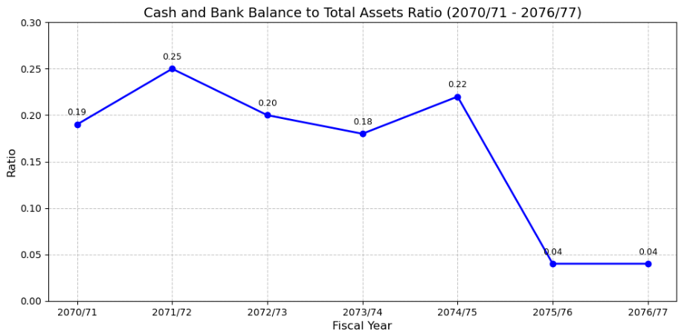
Figure 3: Cash and Bank Balance to Total Assets Ratio
Table 3 and Figure 3 show that the cash and bank balance to total assets ratio of EBL is in a fluctuating trend. EBL's cash and bank balance to total assets ratio was highest at 0.25 times in 2071/72 and lowest in the years 2075/76 and 2076/77 at 0.04 times. The ratio over the past seven years in terms of percentage change reveals significant fluctuations. The ratio increased in 2071/72 by 32 percent, decreased in 2072/73 by 20 percent, fell further in 2073/74 by 10 percent, then rose in 2074/75 by 22 percent. However, it experienced a sharp decline of 78.64 percent in 2075/76 and a further decrease of 4.26 percent in 2076/77.
The average ratio is 0.16, which is lower than 1. This indicates that EBL will not be able to pay off all its liabilities with available cash and cash equivalents. The standard deviation of the analyzed data is 0.085. While this value is lower than the mean, it reflects moderate dispersion in the ratio values over the period. The coefficient of variation (CV) is 53.13 percent, which measures the extent of variability in relation to the population mean. This CV reveals that the ratio of standard deviation to mean is moderately high, indicating noticeable volatility in the cash and bank balance to total assets ratio over the observed years. Higher CV values suggest greater relative variability, which implies more instability in the ratio's performance during this period.
iv)Current Ratio
This ratio is used to find the relation between current assets and current liabilities of the bank. The current ratio is a liquidity ratio that measures a company's ability to pay short term obligations or those due within one year.


Table 6: Current Ratio
(Amount in Rs.)

Fiscal  Year | Current  Assets | Current  Liabilities | Ratio | Percentage  (%)
2070/71 | 63,313,902,806 | 64,519,090,385 | 0.98 | -
2071/72 | 83,419,734,448 | 91,193,583,991 | 0.91 | -7%
2072/73 | 95,007,318,559 | 104,302,113,291 | 0.91 | 0%
2073/74 | 11,964,561,347 | 103,897,018,696 | 0.99 | 9%
2074/75 | 15,554,185,400 | 127,607,799,028 | 0.99 | 0%
2075/76 | 15,295,191,235 | 144,063,326,291 | 0.11 | -89%
2076/77 | 31,123,700,000 | 134,740,000,000 | 0.23 | 109%
Mean |  |  | 0.73
SD |  |  | 0.358
CV |  |  | 49%
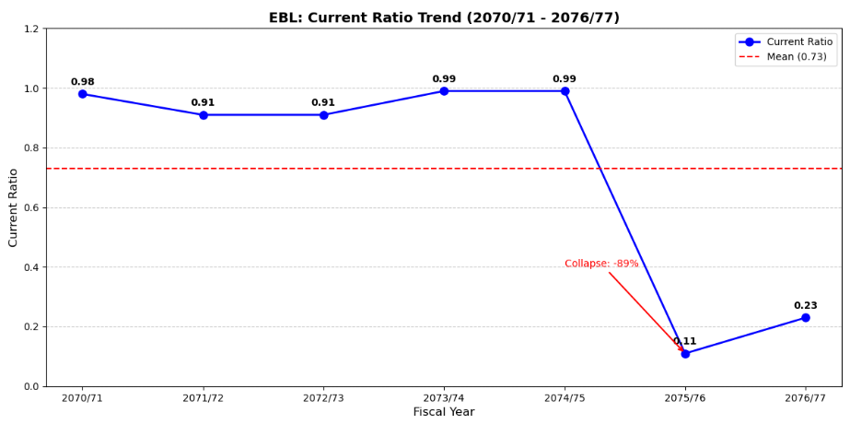
Figure 4: Current Ratio
The above Table 4 and Figure 4 show that the current ratio of EBL has fluctuated significantly over the past seven years. EBL's current ratio was highest at 0.99 times in both 2073/74 and 2074/75, and lowest in the year 2075/76 at 0.11 times. The ratio over this period in terms of percentage change reveals considerable volatility. The ratio decreased by 7% in 2071/72, showed no change in 2072/73, increased by 9% in 2073/74, and again showed no change in 2074/75. However, it experienced a sharp decline of 89% in 2075/76, followed by a substantial increase of 109% in 2076/77. The average ratio is 0.73, which is lower than 1. This indicates that the EBL's current assets are insufficient to meet its current liabilities.
Similarly, the standard deviation of the analyzed data is 0.358, which is higher than the mean, meaning that the numbers are spread out over a wider range. This reflects greater volatility in the relationship between current assets and current liabilities. Likewise, the CV represents the ratio of the standard deviation to the mean. The CV obtained here is 49 percent, which indicates that the ratio of SD to mean is moderately high. A higher ratio of SD to mean suggests increased variability, which implies greater instability in the current ratio performance during this period. This level of volatility indicates a less favorable risk-return trade-off compared to previous assessments.

2.2.2 Profitability Ratio:
A profitability ratio is a measure of profitability, it is a way to measure a company's performance. Profitability is simply the capacity to make a profit. A profit is what is left over from income earned after one has deducted all costs and expenses related to earning the income. It refers to the ability of the company to use its resources to generate revenues in excess of its expenses. Profitability ratios are generally considered to be the basic bank financial ratio in order to evaluate how well bank is performing in terms of profit.
i) Return on Shareholder’s Fund:
This ratio, also called Return in Proprietor’s Fund or Return in Net worth. It measures the percentage of net profit to average shareholder’s fund.

Table 7: Return on Shareholder's Fund
(Amount in Rs.)
Fiscal Year | Net Profit after  Tax | Shareholder’s  Fund | Ratio | Percentage  (%)
2070/71 | 1,549,698,560 | 5,457,147,460 | 28% | 0%
2071/72 | 1,574,352,443 | 6,890,377,025 | 23% | -18%
2072/73 | 1,730,207,025 | 8,514,088,112 | 20% | -13%
2073/74 | 2,006,247,780 | 11,544,581,880 | 17% | -15%
2074/75 | 2,581,681,778 | 16,134,507,415 | 16% | -6%
2075/76 | 2,754,440,000 | 14,651,462,091 | 19% | 19%
2076/77 | 2,516,200,000 | 18,677,800,000 | 13% | -32%
Mean |  |  | 19.4%
SD |  |  | 4.6%
CV |  |  | 23%
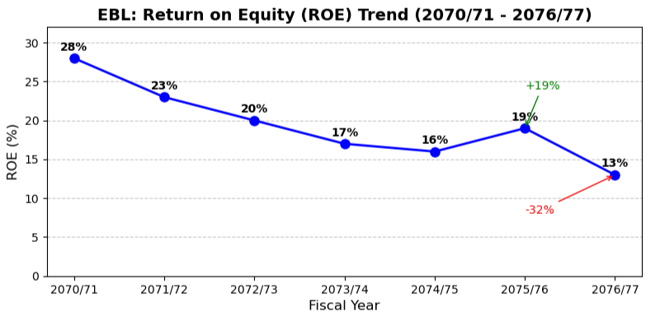
Figure 5: Return on Shareholder's Fund
The above table and figure show that the Return on Equity (ROE) of EBL has fluctuated over the past seven years. EBL's ROE was highest at 28% in 2070/71 and lowest in 2076/77 at 13%. The ratio over this period in terms of percentage change reveals significant variation. The ratio decreased by 18% in 2071/72, 13% in 2072/73, and 15% in 2073/74, followed by a smaller decrease of 6% in 2074/75. However, it increased by 19% in 2075/76 before declining sharply by 32% in 2076/77. The average ROE is 19.4%, indicating that shareholders earned approximately 19.4 rupees for every 100 rupees invested.
Similarly, the standard deviation of the analyzed data is 4.6%, which is lower than the mean, meaning that most of the ROE figures are relatively close to the average. This suggests moderate variability in profitability performance. Likewise, the CV represents the ratio of the standard deviation to the mean. The CV obtained here is 23%, which indicates moderate relative variability in ROE over the observed period. A lower CV generally suggests more consistent returns, though 23% reflects noticeable year-to-year fluctuations in profitability.
ii)Return on Total Assets
Return on Total Assets measures the profitability of the total investment of the company. The ratio is computed by dividing net income after tax by average total assets. The ratio is calculated to measure the profit after tax against the amount invested in total assets to ascertain whether assets are being utilized properly or not.
Table 8: Return on Total Assets
(Amount in Rs.)

Fiscal Year | Net Profit after  Tax | Total Assets | Ratio | Percentage  (%)
2070/71 | 1,549,698,560 | 70,445,082,845 | 28% | -
2071/72 | 1,574,352,443 | 99,152,806,017 | 23% | -18%
2072/73 | 1,730,207,025 | 113,885,046,402 | 20% | -13%
2073/74 | 2,006,247,780 | 116,510,445,575 | 17% | -15%
2074/75 | 2,581,681,778 | 144,811,151,443 | 16% | -6%
2075/76 | 2,754,440,000 | 170,077,533,454 | 19% | 19%
2076/77 | 2,516,200,000 | 185, 023, 189,704 | 13% | -32%
Mean |  |  | 19.4%
SD |  |  | 4.6%
CV |  |  | 23%

Figure 6: Return on Total Assets

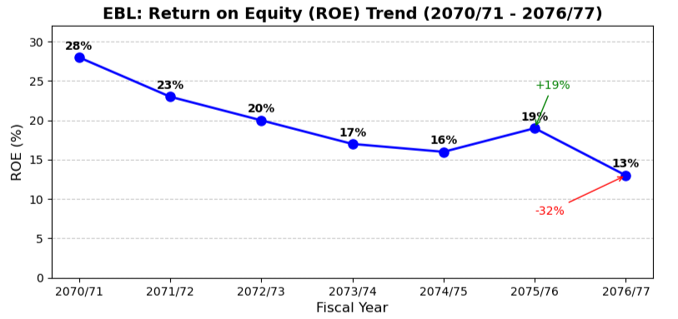

The above table and figure show that the Return on Equity (ROE) of EBL has fluctuated over the past seven years. EBL's ROE was highest at 28% in 2070/71 and lowest in 2076/77 at 13%. The ratio over this period in terms of percentage change reveals significant variation. The ratio decreased by 18% in 2071/72, 13% in 2072/73, and 15% in 2073/74, followed by a smaller decrease of 6% in 2074/75. However, it increased by 19% in 2075/76 before declining sharply by 32% in 2076/77. The average ROE is 19.4%, indicating that shareholders earned approximately 19.4 rupees for every 100 rupees invested.
Similarly, the standard deviation of the analyzed data is 4.6%, which is lower than the mean, meaning that most of the ROE figures are relatively close to the average. This suggests moderate variability in profitability performance. Likewise, the CV represents the ratio of the standard deviation to the mean. The CV obtained here is 23%, which indicates moderate relative variability in ROE over the observed period. A lower CV generally suggests more consistent returns, though 23% reflects noticeable year-to-year fluctuations in profitability.
iii)Earnings per Share (EPS)
EPS simply shows the profitability of the firm on a per share basis. It is calculated from the point of view of the ordinary shareholders.
Table 9: Earning Per Share
(Amount in Rs.)

Fiscal  Year | Net Profit after  Tax | No. of share | EPS | Percentage  (%)
2070/71 | 1,549,698,560 | 18,012,391 | 86 | 0%
2071/72 | 1,574,352,443 | 20,173,878 | 78 | -9%
2072/73 | 1,730,207,025 | 20,173,878 | 86 | 10%
2073/74 | 2,006,247,780 | 60,352,269 | 33 | -62%
2074/75 | 2,581,681,778 | 60,352,269 | 43 | 30%
2075/76 | 2,754,440,000 | 80,268,636 | 34 | -20%
2076/77 | 2,516,200,000 | 84,702,000 | 29 | -13%
Mean |  |  | 55.69
SD |  |  | 24.09
CV |  |  | 43%
Sources: Annual Report of EBL

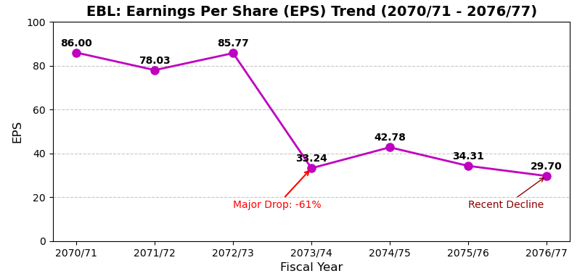
Figure 7: Earning Per Share

The table and figure show that the Earnings Per Share (EPS) of EBL has experienced significant fluctuations over the past seven years. EBL's EPS was highest at 86.00 in 2070/71 and lowest in 2076/77 at 29.70. The ratio over this period in terms of percentage change reveals considerable volatility. The ratio decreased by 9% in 2071/72, increased by 10% in 2072/73, then declined sharply by 61% in 2073/74, followed by a 29% increase in 2074/75. However, it decreased by 20% in 2075/76 and further declined by 13% in 2076/77. The average EPS is 55.69, indicating the average earnings generated per outstanding share over the period.

Similarly, the standard deviation of the analyzed data is 24.09, which is moderately high relative to the mean, meaning the EPS figures show substantial dispersion. This suggests significant variability in per-share profitability performance. Likewise, the CV represents the ratio of the standard deviation to the mean. The CV obtained here is 43%, which indicates high relative variability in EPS over the observed period. This level of volatility suggests inconsistent earnings performance, which may affect investor confidence.

iv)Dividend Per Share (DPS):
This ratio is calculated by dividing the Dividend payable to Equity Shareholders by Number of Equity Shares.

Table 10: Dividend Per Share
(Amount in Rs.)
Fiscal Year | Dividend payable to equity shareholders | No. of equity share outstanding | DPS | Percentage  (%)
2070/71 | 920,395,772 | 18,012,391 | 51 | 0%
2071/72 | 141,122,877 | 20,173,878 | 7 | -86%
2072/73 | 106,495,939 | 20,173,878 | 5 | -29%
2073/74 | 110,422,513 | 60,352,269 | 2 | -60%
2074/75 | 1,600,000,000 | 60,352,269 | 27 | 1349%
2075/76 | 1,003,357,959 | 80,268,636 | 13 | -53%
2076/77 | 1,187,800,000 | 84,702,000 | 14 | 12%
Mean |  |  | 16.89
SD |  |  | 16.27
CV |  |  | 96%

Sources: Annual Report of EBL
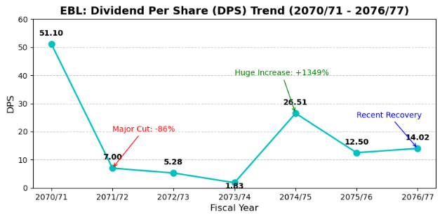
Figure 8: Dividend Per Share

The table and figure show that the Dividend Per Share (DPS) of EBL has experienced extreme fluctuations over the past seven years. EBL's DPS was highest at 51.10 in 2070/71 and lowest in 2073/74 at 1.83. The ratio over this period in terms of percentage change reveals dramatic volatility. The ratio decreased by 86% in 2071/72, 25% in 2072/73, and 65% in 2073/74, then increased substantially by 1349% in 2074/75. However, it decreased by 53% in 2075/76 before increasing by 12% in 2076/77. The average DPS is 16.89, indicating the average dividend distributed per share over the period.

Similarly, the standard deviation of the analyzed data is 16.27, which is nearly equal to the mean, meaning the DPS figures show extremely wide dispersion. This suggests very high variability in dividend distribution policy. Likewise, the CV represents the ratio of the standard deviation to the mean. The CV obtained here is 96%, which indicates extremely high relative variability in DPS over the observed period. This level of volatility suggests inconsistent dividend payments, which may significantly affect investor confidence and shareholder satisfaction.

2.2.3 Assets Management Ratio:
It is also known as turnover or efficiency ratio or assets management ratio. It measures how efficiently the firm employs the assets. The asset turnover ratio measures the value of a company's sales or revenues relative to the value of its assets. The asset turnover ratio can be used as an indicator of the efficiency with which a company is using its assets to generate revenue. Higher the asset turnover ratio, the more efficient a company. Conversely, if a company has a low asset turnover ratio, it indicates it is not efficiently using its assets to generate sales.

i) Loan and Advances to Fixed Deposit Ratio:
Loan and advances are the assets of the bank and fixed deposit is the liability. So, this is the ratio between assets and liability. This helps to show the ratio of Loan & advances to fixed deposit. We can also conclude that what part of the credit and advances is initiated against fixed deposit.

Table 11: Loan and Advances to Fixed Deposit Ratio
(Amount in Rs.)
Fiscal Year | Loan and Advance | Fixed Deposit | Ratio | Percentage  (%)
2070/71 | 47,572,024,207 | 14,528,858,311 | 3.2% | -
2071/72 | 54,482,465,225 | 19,784,889,538 | 2.7% | -15.6%
2072/73 | 67,955,107,021 | 25,999,038,315 | 2.6% | -3.7%
2073/74 | 77,287,764,142 | 36,311,502,599 | 4.7% | 80.8%
2074/75 | 94,182,247,596s | 54,063,678,682 | 5.7% | 21.3%
2075/76 | 124,325,225,413 | 52,374,755,000 | 2/37% | -58.4%
2076/77 | 119,069,200,000 | 31,282,100,000 | 3.80% | 60.3%
Mean |  |  | 3.58%
SD |  |  | 1.14%
CV |  |  | 31.84%
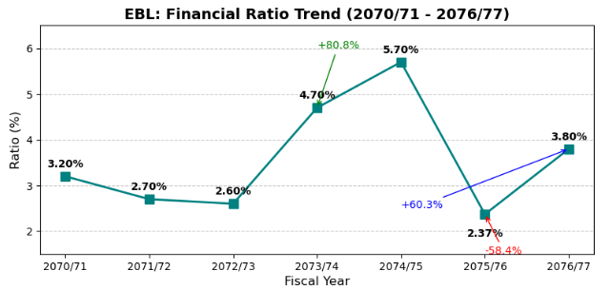
Figure 9: Loan and Advances to Fixed Deposit Ratio
The table and figure show that this financial ratio of EBL has experienced significant fluctuations over the past seven years. The ratio was highest at 5.70% in 2074/75 and lowest in 2075/76 at 2.37%. The year-over-year percentage changes reveal extreme volatility. The ratio decreased by 15.6% in 2071/72 and 3.7% in 2072/73, then increased substantially by 80.8% in 2073/74 and 21.3% in 2074/75. However, it decreased sharply by 58.4% in 2075/76 before rebounding by 60.3% in 2076/77. The average ratio is 3.58%, indicating the typical level of this metric over the period.
Similarly, the standard deviation of the analyzed data is 1.14%, which is moderately high relative to the mean, meaning the ratio values show considerable dispersion. This suggests significant variability in this aspect of EBL's financial performance. Likewise, the CV represents the ratio of the standard deviation to the mean. The CV obtained here is 31.84%, which indicates moderate relative variability in the ratio over the observed period. This level of volatility suggests inconsistent performance in this financial metric.
ii)Loan and Advances to Total Deposit Ratio:
Loan and advances is the investing activities of the bank and total deposit is the deposit amount of the bank collected from its customers. This ratio measures the extent to which the bank is successful to manage its total deposit on loan and advances for the purpose of income generation. A high ratio indicates better mobilization of collected deposit and vice-versa.
However, it should be noted that too high ratio might not be better from liquidity point of view.

Table 12: Loan and Advances to Total Deposit Ratio
(Amount in Rs.)

Fiscal Year | Loan and Advance | Total Deposit | Ratio | Percentage  (%)
2070/71 | 47,572,024,207 | 62,108,135,754 | 77% | 0%
2071/72 | 54,482,465,225 | 83,093,789,957 | 66% | -14%
2072/73 | 67,955,107,021 | 93,735,480,708 | 72% | 9%
2073/74 | 77,287,764,142 | 95,094,461,030 | 81% | 13%
2074/75 | 94,182,247,596 | 115,511,705,922 | 82% | 1%
2075/76 | 124,325,225,413 | 129,810,481,911 | 96% | 17%
2076/77 | 119,069,200,000 | 144,728,300,000 | 82% | -14%
Mean |  |  | 79.4%
SD |  |  | 9.3%
CV |  |  | 11.7%
Source: Annual report of EBL
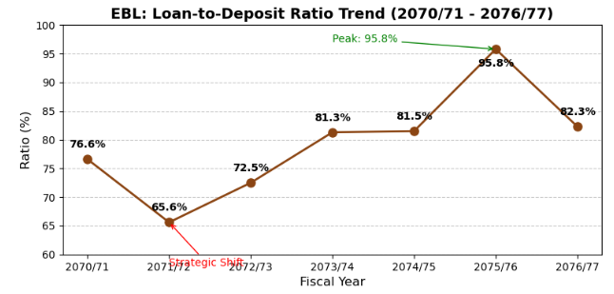
Figure 10: Loan and Advances to Total Deposit Ratio
The above table and figure show that the loan to total deposit ratio of EBL has fluctuated over the past seven years. EBL's ratio was highest at 95.8% in 2075/76 and lowest in 2071/72 at 65.6%. The ratio over the past seven years in terms of percentage change reveals significant variations. The ratio decreased by 14.4% in 2071/72, increased by 10.5% in 2072/73, 12.1% in 2073/74, and 0.2% in 2074/75. It then increased by 17.5% in 2075/76 before decreasing by 14.1% in 2076/77. The average ratio is 79.4%, which indicates that loans averaged 79.4% of total deposits over the period.

Similarly, the standard deviation of the analyzed data is 9.3%, which is moderately lower than the mean, meaning that most ratio values are relatively close to the average. This suggests moderate variability in the bank's lending relative to its deposit base. Likewise, the CV represents the ratio of the standard deviation to the mean. The CV obtained here is 11.7%, which indicates low-to-moderate relative variability in the ratio over the observed period. This level of consistency suggests stable management of loans against deposits.
iii) Loan and Advances to Total Assets Ratio:
This ratio is determined to find out the relationship between credit & advances to total assets. Loan and advances is the part of total assets. This ratio helps to find out that how much proportion of credit & advances to total assets.

Table 13: Loan and Advances to Total Assets
(Amount in Rs.)

Fiscal Year | Loan and  Advance | Total Assets | Ratio | Percentage  (%)
2070/71 | 47,572,024,207 | 70,445,082,845 | 68% | 0%
2071/72 | 54,482,465,225 | 99,152,086,017 | 55% | -19%
2072/73 | 67,955,107,021 | 113,885,046,402 | 60% | 9%
2073/74 | 77,287,764,142 | 116,510,445,575 | 66% | 10%
2074/75 | 94,182,247,596 | 144,811,151,443 | 65% | -2%
2075/76 | 124,325,225,413 | 170,077,533,454 | 73% | 12.5%
2076/77 | 119,069,200,000 | 185, 023, 189,704 | 64% | -11.9%
Mean |  |  | 64.4%
SD |  |  | 5.3%
CV |  |  | 8.2%
Source: Annual Report of EBL
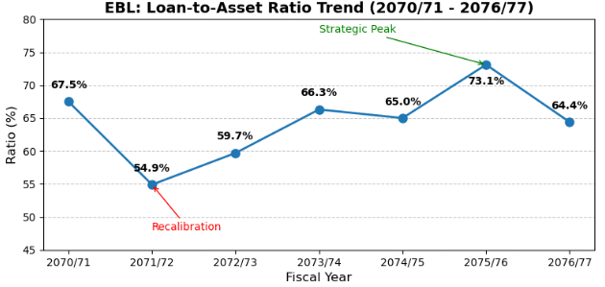
Figure 11: Loan and Advances to Total Assets Ratio
The above table and figure show that the loan to total assets ratio of EBL has fluctuated over the past seven years. EBL's ratio was highest at 73.1% in 2075/76 and lowest in 2071/72 at 54.9%. The ratio over the past seven years in terms of percentage change reveals significant variations. The ratio decreased by 18.7% in 2071/72, increased by 8.7% in 2072/73 and 11.1% in 2073/74, then decreased by 2.0% in 2074/75. It increased by 12.5% in 2075/76 before decreasing by 11.9% in 2076/77. The average ratio is 64.4%, which indicates that loans averaged 64.4% of total assets over the period.
Similarly, the standard deviation of the analyzed data is 5.3%, which is lower than the mean, meaning that most ratio values are relatively close to the average. This suggests moderate variability in the bank's loan deployment relative to its asset base. Likewise, the CV represents the ratio of the standard deviation to the mean. The CV obtained here is 8.2%, which means that the ratio of SD to mean is low. Lower the ratio of SD to mean, better the risk return trade off.

CHAPTER - III

SUMMARY AND CONCLUSION

3.1 Summary
The study is mainly based on secondary sources. All data are taken from EBL annual report, literature publication, balance sheet, profit and loss account, different website, related books and booklets, journals and articles. After collecting data from different sources, it is analyzed by using financial and statistical tools. Findings are drawn by applying various financial tools viz. liquidity, profitability and assets management ratio and statistical tools: mean, standard deviation and coefficient of variation of cash and bank balance and total deposit. In an attempt to fulfill the objectives of the research work, all secondary data are compiled, processed and tabulated as per necessity and figures, diagrams and different types of chart are also used.
This study suffers from different Limitation; it considers study of only EBL because of time and resource are the constraints of the study. For the purpose of our study, here we have analyzed the financial performance of Everest Bank Limited over the period of FY 2070/71 to FY 2076/77. To evaluate the financial performance of the bank, we have divided the whole report to different chapters. In every chapter, there are several sub-chapters. The first Introduction chapter gives background information about the project work, introduction of
Everest Bank Limited, Review related studies etc. The second chapter called Presentation and Analysis of Data; we tried to analyze the financial performance of the bank. Therefore, the study may not be generalized in all cases and accuracy depends upon the data collected and provided by the organization.

3.2 Conclusion
The major findings from the study lead to the following conclusions:
- Cash and Bank Balance to Total Assets Ratio shows a fluctuating trend during the study period. The mean ratio is 0.16, which is significantly below 1. This indicates EBL may face challenges in meeting immediate obligations without relying on other funding sources.
- Cash and Bank Balance to Total Deposit Ratio has a mean of 0.25 times. This suggests the bank maintains limited liquidity buffers against deposits, potentially affecting its ability to extend credit terms to customers.
- Current Ratio averages 0.73 during the study period, indicating current liabilities exceed current assets. The bank needs to either decrease current liabilities or increase current assets to achieve a ratio ≥1 for better short-term solvency.
- Return on Shareholders' Fund (ROE) averages 19.4%, demonstrating satisfactory profitability. However, the ratio declined significantly from 28% to 13% during the study period, indicating emerging profitability challenges.
- Return on Total Assets (ROA) averages 1.68%, suggesting the need for improved asset utilization efficiency to enhance earnings performance.
- EPS decreased substantially in 2073/74 due to share dilution. While it increased by 29% in 2074/75, it subsequently declined to 29.70 by 2076/77, showing inconsistent per-share earnings growth.
- DPS increased remarkably to Rs.26.51 in 2074/75 from Rs.1.83 in 2073/74. However, the extreme fluctuations (1349% increase followed by 53% decrease) create shareholder uncertainty regarding dividend stability.
- Loan and Advances to Fixed Deposit Ratio averages 266.7%, indicating aggressive lending relative to deposit base. This high ratio suggests potential liquidity constraints during unforeseen fund requirements.
- Loan and Advances to Total Deposit Ratio averages 79.4%, reflecting effective mobilization of deposits for income generation through lending activities.
- Loan and Advances to Total Assets Ratio averages 64.4%, demonstrating satisfactory utilization of assets for credit deployment while maintaining balanced asset composition.

BIBLIOGRAPHY
- Ahmed, M. B. (2009). Measuring the Performance of Islamic Banks by Adapting Conventional Ratios (Working Paper No. 16). German University in Cairo Faculty of Management Technology.
- Almumani, M. A. (2014). Evaluating the Financial Performance of Banks Using Financial Ratios: A Case Study of Erbil Bank for Investment and Finance. European Journal of Accounting Auditing and Finance Research, *2*, 162-177.
- Haque, I. (2011). Comparative Study between Public Sector Banks & Private Sector Banks. International Journal of Management & Innovation.
- Hannan, A. S., & Shaheed, A. (1998). Financial Position and Performance Analysis of Bangladesh Shilpa Bank. Islamic University Studies, *1*.
- Kiyota, H. (2009). Efficiency of Commercial Banks in Sub-Saharan Africa: A Comparative Analysis of Domestic and Foreign Banks. Paper presented at CSAE Conference on Economic Development in Africa, University of Oxford.
- Kumbirai, M., & Webb, R. (2010). African Review of Economics and Finance, *2*(1). Rhodes University.
- O’Donnell, C. J., & van der Westhuizen, G. (2002). Regional Comparisons of Banking Performance in South Africa. The South African Journal of Economics, *70*(3), 485–518.
- Peterson, P. P., & Fabozzi, F. J. (1999). Analysis of Financial Statements (Vol. 54). John Wiley & Sons.
- Samad, A. (2004). Bahrain Commercial Bank’s Performance during 1994-2001. Credit and Financial Management Review, *10*(1), 33–40.
- Sinha, G. (2007). Financial Statement Analysis. PHI Learning.
Official Reports & Digital Sources:
11. Everest Bank Limited. (2014-2020). *Annual Reports (FY 2070/71 - 2076/77)*. https://www.ebl.com.np/investor-relations/financial-reports
12. Investopedia. (n.d.). Financial Ratios. Retrieved June 20, 2025, from https://www.investopedia.com/terms/f/financialratio.asp

